* Select bucket and open the file list  
    
  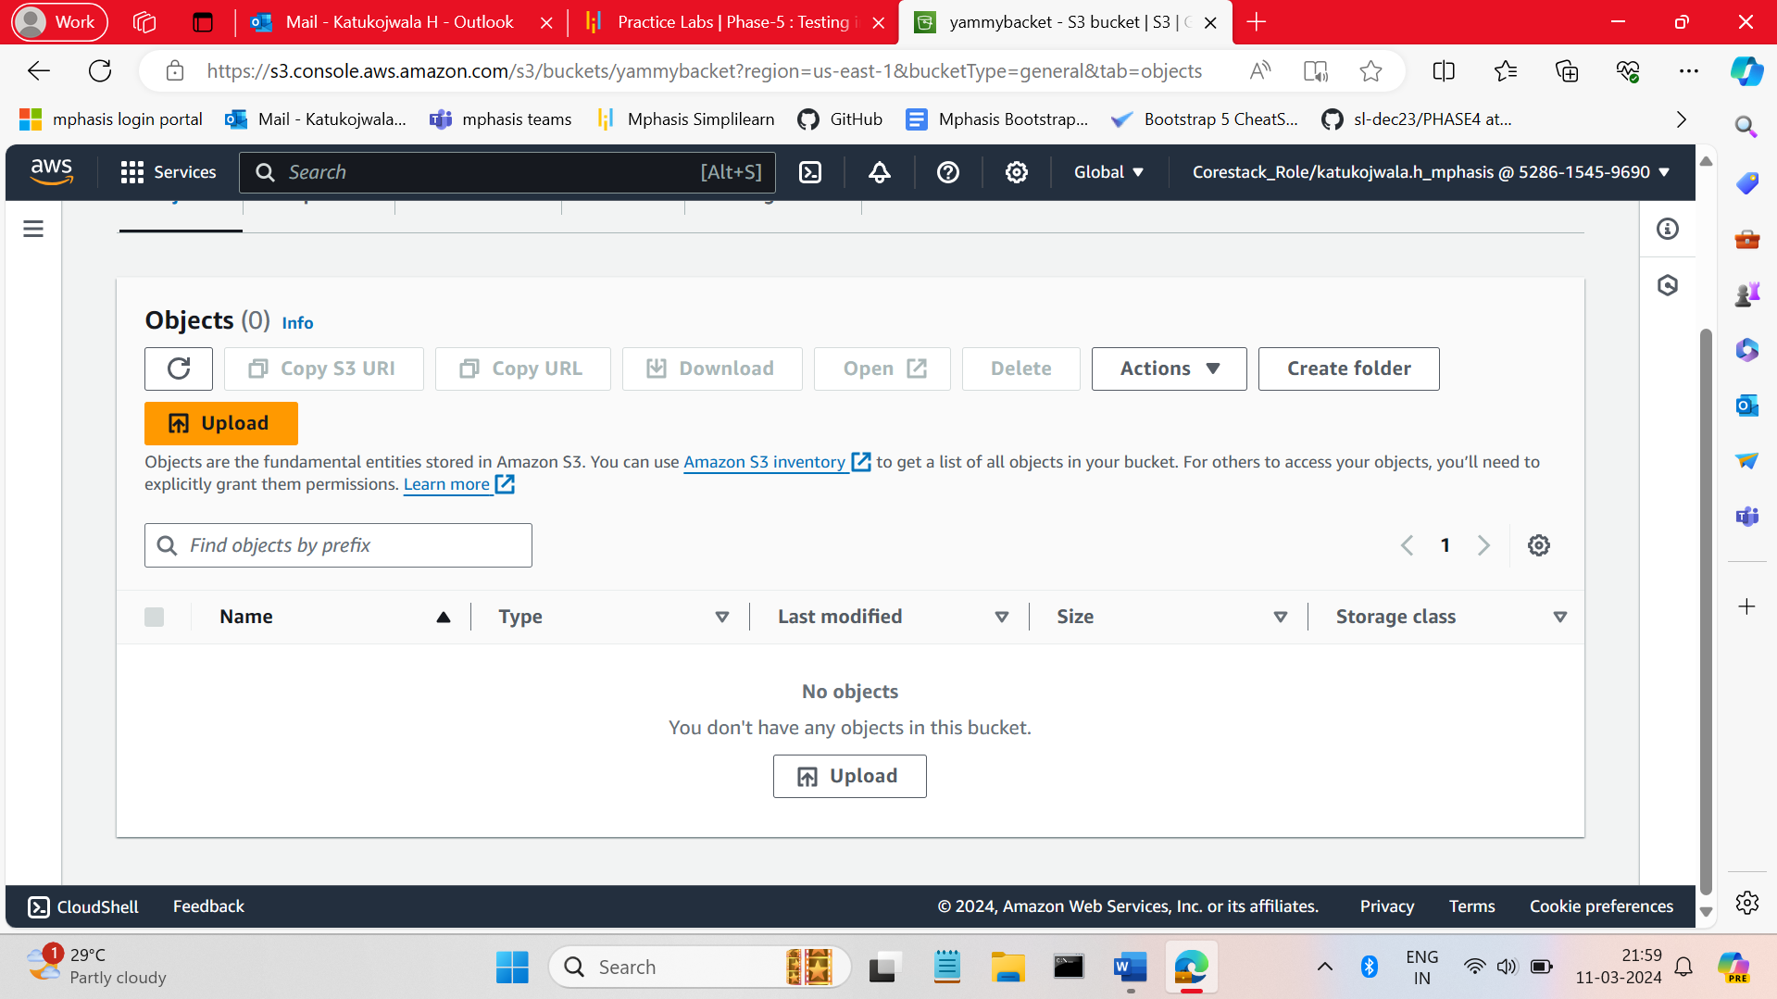
* Upload files (in filer are objects).  
    
    
  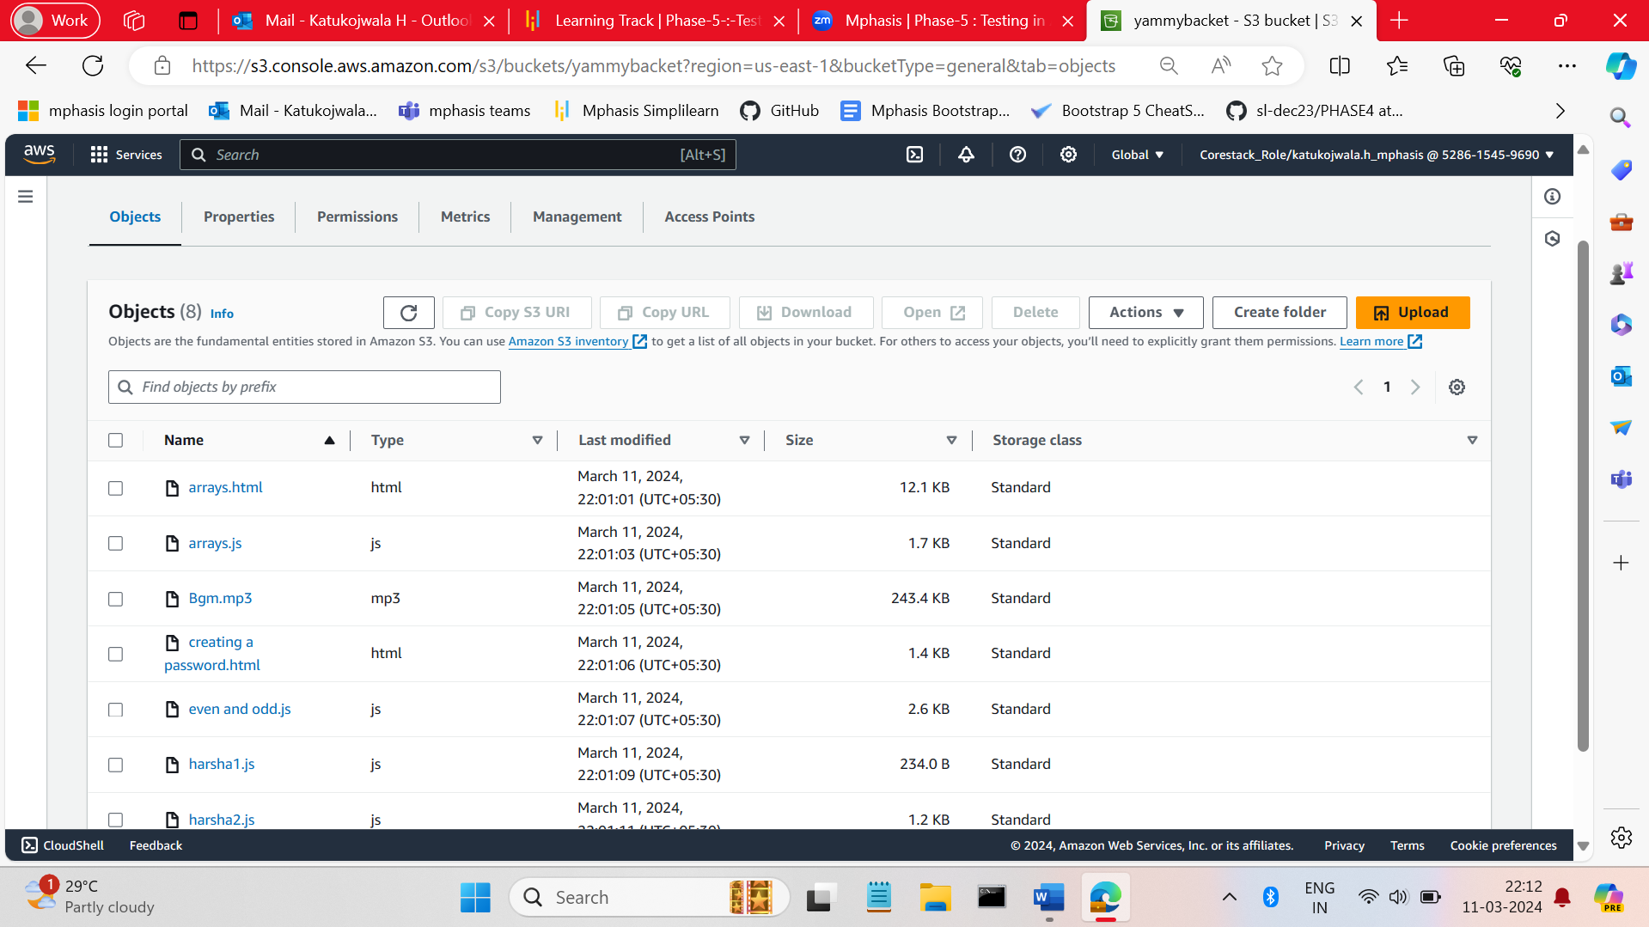
* Select the some prenuclear file and click on the file  
    
  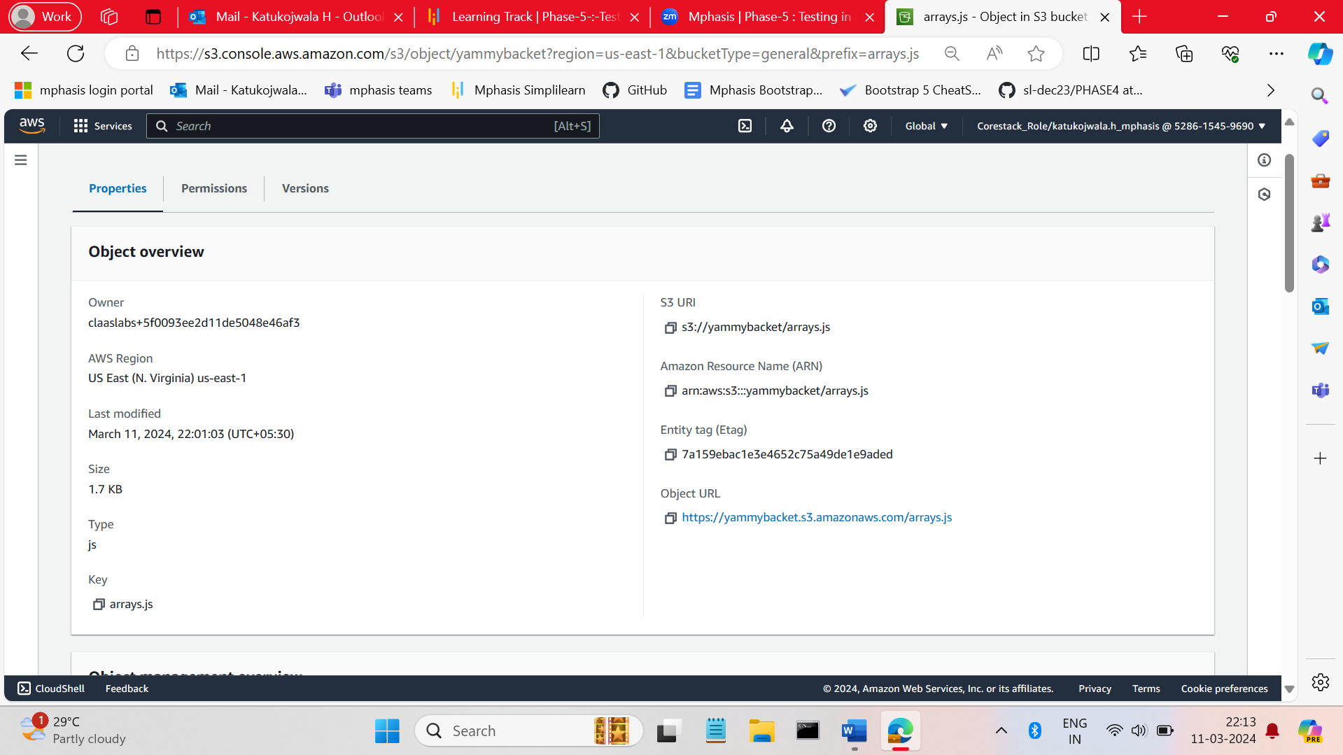
* Scroll down you can find the session storage class click on edit button.  
    
  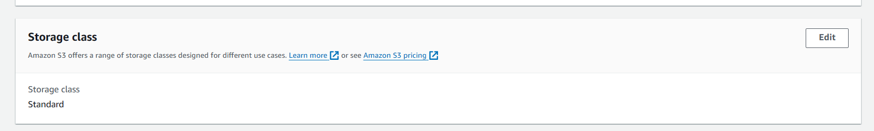
* Select the storage class and click on save changes.  
    
  